**Hello Team!** **Consider the below two tables**:

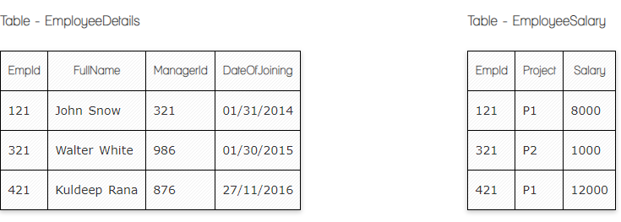

**Ques.1. Write a SQL query to fetch the count of employees working in project 'P1'.**

**Your Answer:**

SELECT COUNT(EmpId)

FROM EmployeeSalary

WHERE Project=’P1’

Group BY Project;

**Ques.2. Write a SQL query to fetch employee names having salary greater than or equal to 5000 and less than or equal 10000.**

**Your Answer:**

Select EmployeeDetails.Fulname, EmployeeSalary.Salary

From EmployeeDetails Where salary between 5000 and 1000

Inner join EmployeeSalary on EmployeeDetails.EmpID= EmployeeSalary. EmpID

**Ques.3. Write a SQL query to fetch count of employees sorted by project's count in descending order.**

**Your Answer:**

SELECT COUNT(EmpId), Project

FROM EmployeeSalary

GROUP BY Project

ORDER BY COUNT(EmpId) DESC

**Ques.4. Write a query to fetch employee names and salary records. Return employee details even if the salary record is not present for the employee.**

**Your Answer:**

SELECT EmployeeDetails.EmpId, EmployeeSalary. Salary FROM EmployeeDetails

LEFT JOIN EmployeeSalary ON EmployeeDetails.EmpId = EmployeeSalary.EmpId

**Ques.5. Write a SQL query to create an empty table with ‘Test’ name.**

**Your Answer:**

CREATE TABLE Test

**Ques.6. Write a SQL query to delete an empty table with ‘Test’ name.**

**Your Answer:**

DROP TABLE Test

**Ques.7. Write a SQL query to fetch all the Employees details from EmployeeDetails table who joined in Year 2016.**

**Your Answer:**

Select * from EmployeeDetails where DateOfJoining = 2016

**Ques.8. Write a SQL query to insert new record to the EmployeeDetails table with any data.**

**Your Answer:**

INSERT INTO EmployeeDetails(EmpID, FullName, ManagerID, DateOfJoinig)

VALUES (10, ‘Anna’, 50, 10/03/2015)

**Ques.9. Write a SQL query to update EmployeeSalery table with setting Salary to 2000 for Project P2.**

**Your Answer:**

UPDATE EmployeeSalary SET Salary=2000 WHERE Project-‘P2’

**Ques.10. Write a SQL query to right join both tables and draw the results.**

**Your Answer:**

SELECT Orders.OrderID, Employees.LastName, Employees.BirthDate FROM Orders

RIGHT JOIN Employees ON Orders.EmployeeID= Employees. EmployeeID

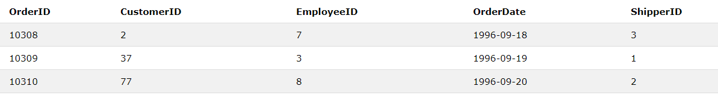

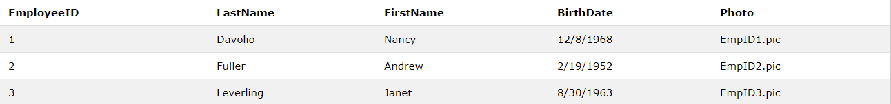

**Now take these two tables:**

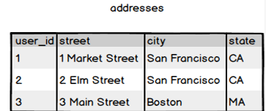

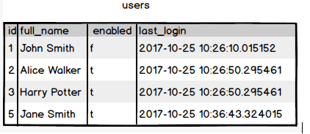

**Ques.11. Write a SQL query to fetch all users full_name from San Francisco.**

**Your Answer:**

SELECT users.full_name, addresses.city

FROM users INNER JOIN addresses ON users.id = addresses.user_id

WHERE addresses.city = ‘San Francisco’

**Ques.12. Write a SQL query to fetch all users full_name, last_login who are enabled**

**Your Answer:**

SELECTfull_name, last_loginFROMusers WHERE enabled = 't'

**Ques.13. Write a SQL query to fetch all users full_name who are not from Main street**

**Your Answer:**

SELECT users.full_name, addresses.street

FROM users LEFT JOIN addresses ON users.id = addresses.user_id

WHERE NOT street = '3 Main street' or ‘San Francisco’

**Ques.14. Write a SQL query to fetch all users full_name who are from Main street or San Francisco**

**Your Answer:**

SELECT users.full_name, addresses.street

FROM users LEFT JOIN addresses ON users.id = addresses.user_id

WHERE street = '3 Main street' or ‘San Francisco’

**Ques.15. Write a SQL query to fetch user full_name who is equal to user_id from Boston (find user_id value in sub_query)**

**Your Answer:**

SELECT full_name FROM usesrs WHERE user_id = (SELECT user_Id FROM addresses WHERE city=’Boston’)